Scenario 6: Cross-Account S3 Access — Allowing a User From Mumbai Account to Access a Bucket in Virginia Account
Mumbai user-testuser , needs access to view bucket of Virginia account user bucket.
A user testuser in the Mumbai AWS account
(Account ID: 277707115759)
needs access to an S3 bucket owned by the Virginia AWS account
(Account ID: 669155638206).
The bucket in Virginia is created by IAM user suchi-east-us, named:
suchi-east-us
This is a cross-account S3 access scenario using a Bucket Policy + IAM Policy.
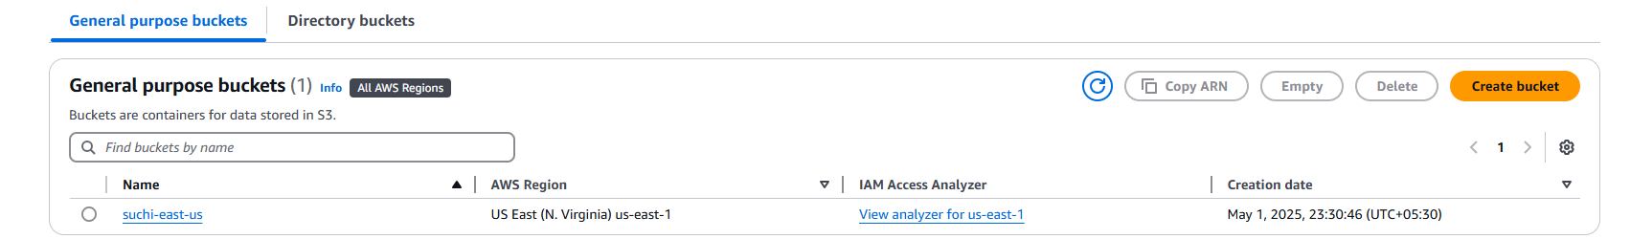
Scenario is that Mumbai account user -testuser needs to access suchi-east-us bucket in Virginia account.
How Cross-Account S3 Access Works
You must configure two things:
1. Bucket Policy (in Virginia account)
— Allows the external user (testuser) to access the bucket
2. IAM Policy (in Mumbai account)
— Lets testuser send requests to that external bucket
Both must be present for access to work.

Step 1: in the Suchi-East-us bucket we need to allow this testuser to access the bucket.
Go to s3>suchi-east-us>permissions>bucket policy.
And edit
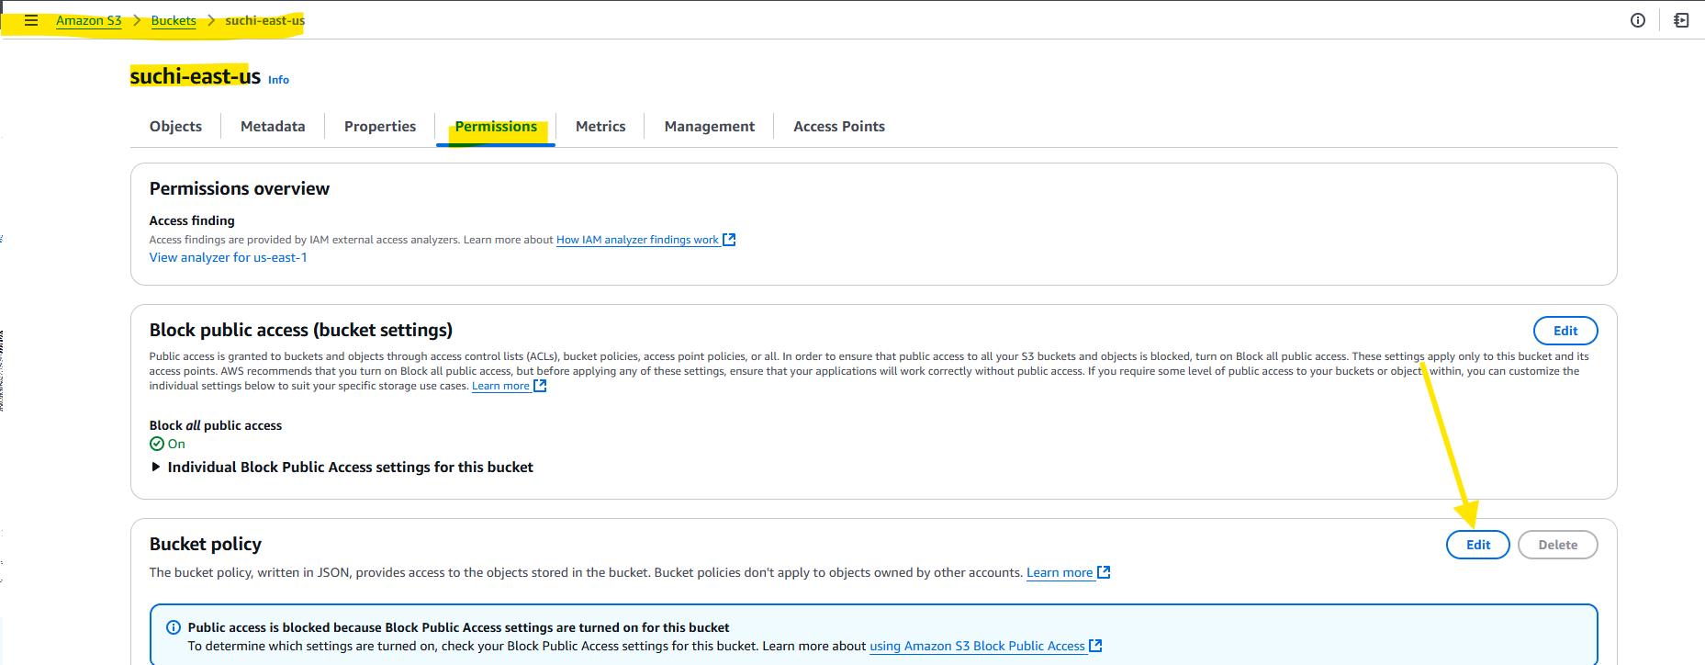
Step 2: if you have the policy just paste it .
Or else go for policy generator to generate the policy.
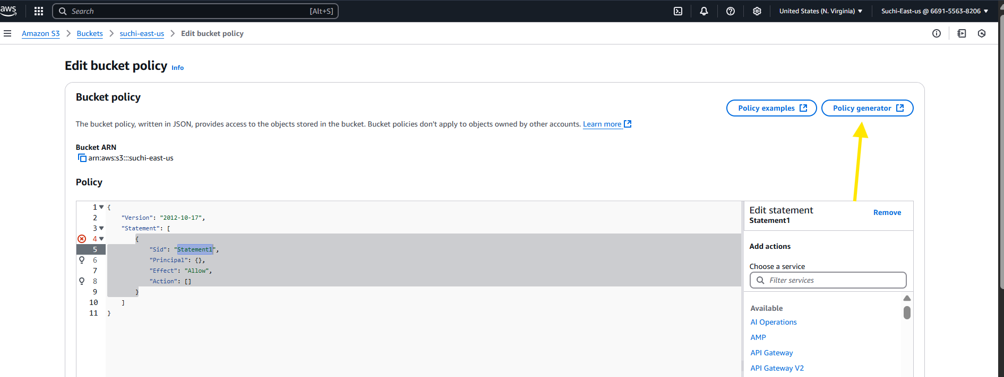
Step 3: refer the below snip for the attributes
Principal name – testuser’s arn name
ARN – bucket’s arn
And then select add statement.
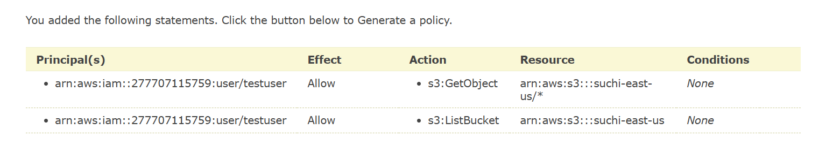
Step 4: copy the policy and past it the bucket policy
{
"Version": "2012-10-17",
"Id": "Policy1746266326861",
"Statement": [
{
"Sid": "Stmt1746266291340",
"Effect": "Allow",
"Principal": {
"AWS": "arn:aws:iam::277707115759:user/testuser"
},
"Action": "s3:GetObject",
"Resource": "arn:aws:s3:::suchi-east-us/*"
},
{
"Sid": "Stmt1746266324397",
"Effect": "Allow",
"Principal": {
"AWS": "arn:aws:iam::277707115759:user/testuser"
},
"Action": "s3:ListBucket",
"Resource": "arn:aws:s3:::suchi-east-us"
}
]
}

Now the testuser can view the suchi-east-us’s bucket.
Note: that users can only view, access modify bucket via CLI. It won’t be visible via console.
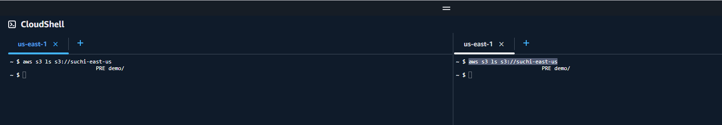

Troubleshooting:
1.if you follow this step but still not able to view the bucket. Ensure testuser don’t have any deny s3 policy.
2. even though user as an IAM policy telling to allow s3. Still not able to access.
- attach an IAM policy to testuser for accessing s3 bucket of Another account (here its viriginia account).
Example:
{
"Version": "2012-10-17",
"Statement": [
{
"Sid": "VisualEditor0",
"Effect": "Allow",
"Action": [
"s3:GetObject",
"s3:ListBucket"
],
"Resource": [
"arn:aws:s3:::arn:aws:s3:::suchi-east-us",
"arn:aws:s3:::/arn:aws:s3:::suchi-east-us/*"
]
}
]
}

